Supplementary information
Autonomous Self-Healable, Ag Nanowire-Polymer Composite Flexible Electrode for Underwater Sensors

Zhengyang Kong¹†, Elvis K. Boahen¹†, Hayoung Lim¹, Do Hwan Kim^{1,2,3}*
¹Department of Chemical Engineering, Hanyang University, Seoul, Korea
²Institute of Nano Science and Technology, Hanyang University, Seoul, Korea
³Clean-Energy Research Institute, Hanyang University, Seoul, Korea

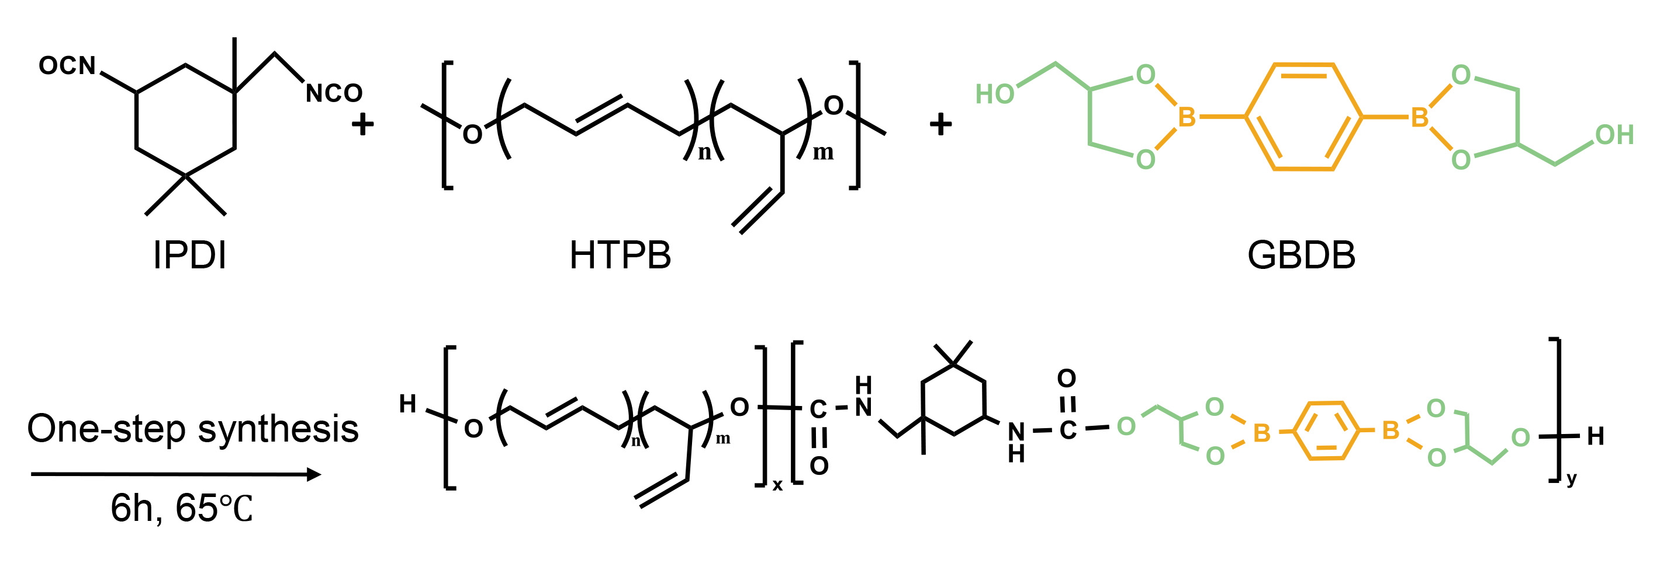

Fig. S1. Synthesis route of BPUs

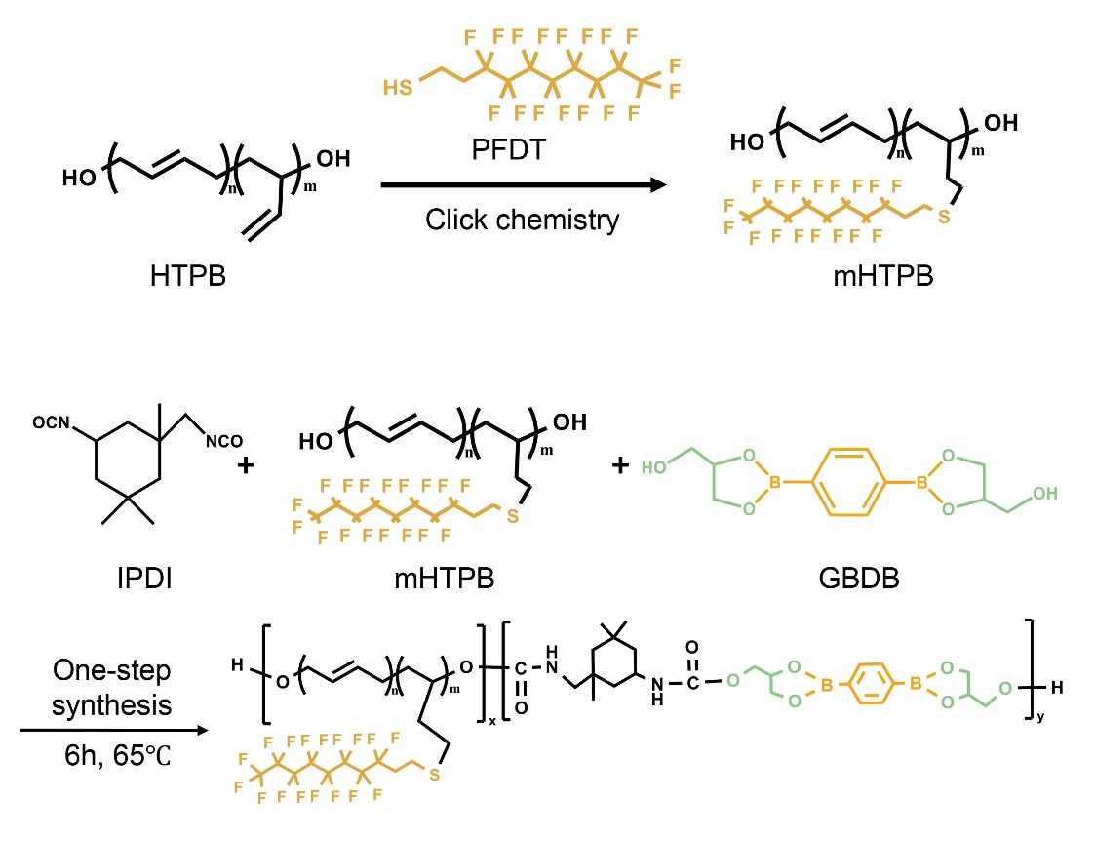
Fig. S2. Functionalization of HTPB and synthesis route of FPU

Table S1. The componential mole ratios of various BPUs.
Batch  NO. | Components |  |  | Catalyst | Hard Segments  (%) | Mw  (g/mol) | PDI | Content of GBDB (wt%)
Batch  NO. | GB (g) | HTPB (g) | IPDI (ml) | DBTDL (g)
BPU-1 | 1.0 | 10 | 1.7 | 0.25 | 21.3 | 3.5 | 2.3 | 7.9
BPU-2 | 1.5 | 10 | 2.2 | 0.25 | 27.0 | 3.9 | 2.4 | 10.9
BPU-3 | 2.0 | 10 | 2.6 | 0.25 | 31.5 | 3.7 | 2.2 | 13.7
BPU-4 | 2.5 | 10 | 3.1 | 0.25 | 35.9 | 3.5 | 2.1 | 16.0
BPU-5 | 3.0 | 10 | 3.5 | 0.25 | 39.4 | 3.6 | 2.3 | 18.2

Table S2. The componential mole ratios of various BPUs.
Sample | Tensile strength (MPa) | Elongation at break (%) | Modulus (MPa) | Toughness (MJ/m³)
BPU-1 | 0.83±0.04 | 1213±9 | 0.26±0.01 | 4.36±0.34
BPU-2 | 0.95±0.03 | 1132±6 | 0.30±0.01 | 5.25±0.65
BPU-3 | 1.47±0.03 | 1098±9 | 0.42±0.01 | 7.81±0.52
BPU-4 | 2.20±0.01 | 961±11 | 1.30±0.02 | 10.21±0.19
BPU-5 | 2.61±005 | 594±5 | 0.87±0.01 | 7.45±0.23

